**Project Initialization and Planning Phase**

|  |  |
| --- | --- |
| Date | 05 JUNE 2024 |
| Team ID | SWTID1720451040 |
| Project Name | Ecommerce Shipping Prediction Using Machine Learning |
| Maximum Marks | 3 Marks |

**Define Problem Statements (Customer Problem Statement Template):**

E-commerce companies may find it difficult to accurately forecast shipment schedules in order to control client expectations. Conflicting estimations can arise from the current methods' reliance on dated data and oversimplified models. The goal is to create a robust forecasting model that accounts for factors including product kind, destination, carrier performance, and variations in seasonal demand. This model should make use of machine learning approaches to increase delivery window forecast accuracy and decrease under- or overestimation, which can negatively affect customer satisfaction and retention.

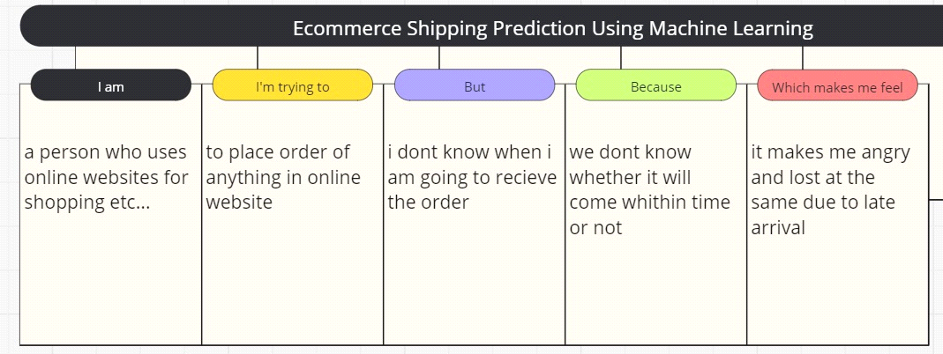

Reference: <https://miro.com/templates/customer-problem-statement/>

|  |  |  |  |  |  |
| --- | --- | --- | --- | --- | --- |
| **Problem**  **Statement (PS)** | **I am**  **(Customer)** | **I’m trying to** | **But** | **Because** | **Which makes me feel** |
| PS-1 | I’m a female customer | I’m trying toplace an order in online website | But I don’t know when I am going to recieve the order | We don’t know whether it will come within time or not | Which makes me feel angry and lost at the same due to late arrival |
| PS-2 | I’m a male customer | to place an order | I am afraid of online scams that are going around | We don’t know whether the product is real fake | It makes me angry and also makes me cry because my money is getting wasted. |